**FIT3179 Data Visualisation 1**

**The Salary Equation: What Variables Determine How Much You Earn?**

**Prepared by:**

Bryan Jun Kit Wong

32882424

1000 words (excluding cover and references)

**Visualisation URL:**

<https://public.tableau.com/views/Assignment1_16927539641170/Dashboard1?:language=en-US&publish=yes&:display_count=n&:origin=viz_share_link>

**Domain**

This visualisation focuses on how individual demographic characteristics, such as race, gender, job title and experience relate to salaries.

**Why?**

The visualisation is useful and engaging for the average user as it reveals how different factors affect income levels. Through these visuals, individuals can better equip themselves to make informed choices about their careers. Furthermore, the visualisation can spotlight income inequalities rooted in gender, ethnicity, or other demographic factors. This can foster meaningful dialogues on achieving wage parity and promoting equitable treatment within the workplace.

**Who?**

This visualisation is tailored for anyone curious about the dynamics of income generation. Job seekers can find guidance in understanding how their choices impact their earning potential. Employees can also gain insights into negotiating fair compensation.

**What?**

The visualisation draws data from a variety of sources, such as surveys, job posting sites, and other public data. The data has 6704 points, with five variables: age, experience, job title, education level, and salary. The data is useful for revealing the patterns and trends in salary levels based on individual characteristics.

**Why and How?**

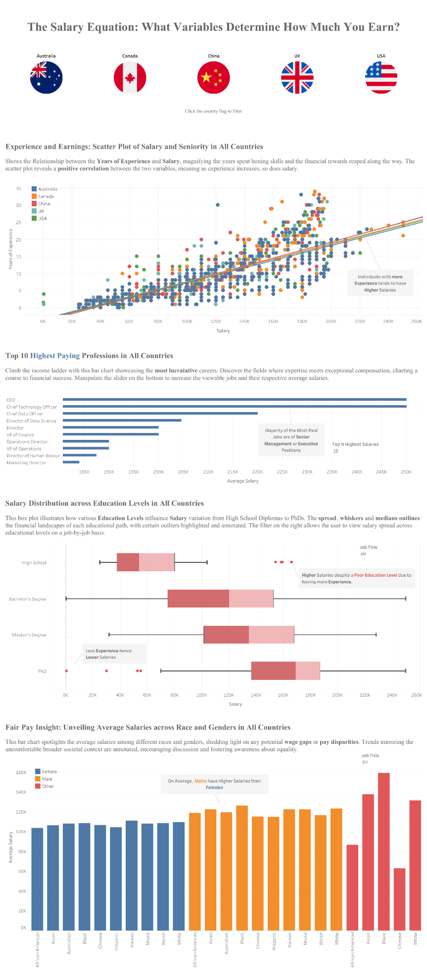

Figure 1.1: The entire Data Visualisation.

Figure 1.2: Interactive buttons to filter idioms by countries.

Figure 1.2 above showcases a unique feature - interactive buttons allowing users to filter the data on idioms by country. Through this, users can customise their experiences and see the data that are the most relevant or interesting to them. Alternatively, users can choose to make no selection, enabling them to view data for all countries at once and compare the differences in data across different countries.

**Scatter Plot**

Figure 1.3: Scatter Plot of Years of Experience against Salary

The scatter plot idiom was chosen to illustrate the correlation between years of experience and salary. Figure 1.3 above shows a positive correlation between the two variables, indicating that the higher the experience an individual has, the higher their salary. This helps the user to understand how experience affects income and to estimate their salary based on their experience. The scatter plot also helps the user to spot the patterns and outliers in the data, which can reveal interesting trends or anomalies. Users can filter out the scatter plot based on a selected country by pressing any button in Figure 1.2.

**Bar Chart**

Figure 1.4: Bar Chart displaying the top N highest paying jobs.

Figure 1.5: Bar chart displaying the Average Salaries of by Race and Gender.

The bar chart in Figure 1.4 shows the income levels of different jobs clearly and helps the user to identify the highest-paying ones with ease. In Figure 1.5, users can detect any pay disparities easily by comparing the salaries of individuals based on race and gender. Similar to Figure 1.3, the bar charts in Figure 1.4 and Figure 1.5 can be filtered based on selected countries. Moreover, the user can manipulate a slider at the bottom right of the chart in Figure 1.4 to change the number of top-paying jobs to display. Figure 1.5 has a drop-down menu that lets the user select one or more job titles to compare the pay breakdowns for each job. Through this, users are given the freedom to tailor their exploration, fostering a more personalised and insightful interaction with the data. Finally, these bar charts can be filtered via the buttons in Figure 1.2.

**Box Plot**

Figure 1.6: Salary distribution across Educational Levels.

The boxplot idiom in Figure 1.6 was chosen as it can efficiently portray the distribution of salary data, particularly highlighting the median, range, and potential outliers within each educational level. In this case, users can quickly discern patterns, compare distributions, and understand anomalies in the data across the various educational levels. Users can filter out selected job titles to compare the educational impact on said jobs’ salaries. Figure 1.6 can be similarly filtered on a country basis using the buttons in Figure 1.2.

**Design**

**Layout**

The visualisation elements were meticulously aligned along both invisible horizontal and vertical sightlines. This strategic approach ensures precision and clarity in the arrangement of components, enhancing the overall user experience. Each row within the layout serves as a distinct and self-contained idiom, contributing to a seamless and focused exploration.

**Colour**

A consistent colour palette was painstakingly chosen, aiming to enhance comprehension. Colour consistency in annotations and text fosters coherence and aids users in associating specific elements within the various idioms, such as in Figure 1.5. Furthermore, high colour contrast helps differentiate the various data within the idiom.

**Figure-ground**

Interactive elements are strategically placed to draw attention. For example, Figure 1.2 is placed at the top with a bigger size as shown in Figure 1.1.

Figure 2.1: Canada is selected.

Figure 2.1 shows Canada being selected. This action causes all other countries to recede into the background, creating a subdued appearance. This approach emphasises the chosen option while minimising distractions from the unselected elements.

Backgrounds remained a neutral white to ensure the idioms and other essential elements like annotations stand out prominently. This contrast creates a visual distinction that directs users' eyes to the most pertinent aspects of the visualisation. Selective use of bold text, such as in certain annotations or text in Figures 1.3, 1.4, 1.5 and 1.6, was employed to provide additional emphasis on specific information. This technique contributes to enhanced clarity and draws attention to vital details within the visualisation.

**Typography**

Serif typeface is chosen for non-graph text elements like the title and descriptions whereas Sans-serif fonts were chosen for graphical elements like headings and labels. The text layout employed ample spacing and alignment to enhance readability. A consistent font ensured seamless continuity throughout the visualisations.

**Storytelling**

Reader guidance was achieved through a sequential narrative. Idioms were introduced logically, starting with broad insights like generic factors affecting salary in Figure 1.3, and progressively delving deeper into nuanced aspects like the wage gap in Figure 1.5. Annotations accompanied by concise explanations directed attention to significant data points. Filtering options are provided to enable users to interact with the data, creating a coherent and insightful story.

**Bibliography/list of references**

Flaticon. (2023). *Free Flag Icons*. Retrieved from <https://www.flaticon.com/free-icons/flag>

Sudheer, P. (2023). *Salary dataset based on country and race*. Retrieved from <https://www.kaggle.com/datasets/sudheerp2147234/salary-dataset-based-on-country-and-race>

Tableau. (2023). *Build a Boxplot. Retrieved* from <https://help.tableau.com/current/pro/desktop/en-us/actions_parameters.htm?_gl=1%2A14wejtp%2A_ga%2AODM0MjI1MDM1LjE2OTE4MTEyOTA.%2A_ga_8YLN0SNXVS%2AMTY5MzQ2NTY3Ni40MS4xLjE2OTM0NjYyNDYuMC4wLjA.>

Tableau. (2023). *Build a Scatter Plot*. Retrieved from <https://help.tableau.com/current/pro/desktop/en-us/buildexamples_scatter.htm?_gl=1%2A1372ius%2A_ga%2AODM0MjI1MDM1LjE2OTE4MTEyOTA.%2A_ga_8YLN0SNXVS%2AMTY5MzQ2NTY3Ni40MS4xLjE2OTM0NjYwMTguMC4wLjA.>

Tableau. (2023). *Finding the Top N within a Category.* Retrieved from <https://help.tableau.com/current/pro/desktop/en-us/buildexamples_boxplot.htm?_gl=1%2Aajh17r%2A_ga%2AODM0MjI1MDM1LjE2OTE4MTEyOTA.%2A_ga_8YLN0SNXVS%2AMTY5MzQ2NTY3Ni40MS4xLjE2OTM0NjYzMzguMC4wLjA.>

Tableau. (2023). *Parameter Actions*. Retrieved from <https://help.tableau.com/current/pro/desktop/en-us/actions_parameters.htm?_gl=1%2A14wejtp%2A_ga%2AODM0MjI1MDM1LjE2OTE4MTEyOTA.%2A_ga_8YLN0SNXVS%2AMTY5MzQ2NTY3Ni40MS4xLjE2OTM0NjYyNDYuMC4wLjA.>

Tableau. (2023). *Set Actions*. Retrieved from <https://help.tableau.com/current/pro/desktop/en-us/buildexamples_scatter.htm?_gl=1%2A1372ius%2A_ga%2AODM0MjI1MDM1LjE2OTE4MTEyOTA.%2A_ga_8YLN0SNXVS%2AMTY5MzQ2NTY3Ni40MS4xLjE2OTM0NjYwMTguMC4wLjA.>

**Appendix**

**Five Design Sheets**

**Sheet 1**

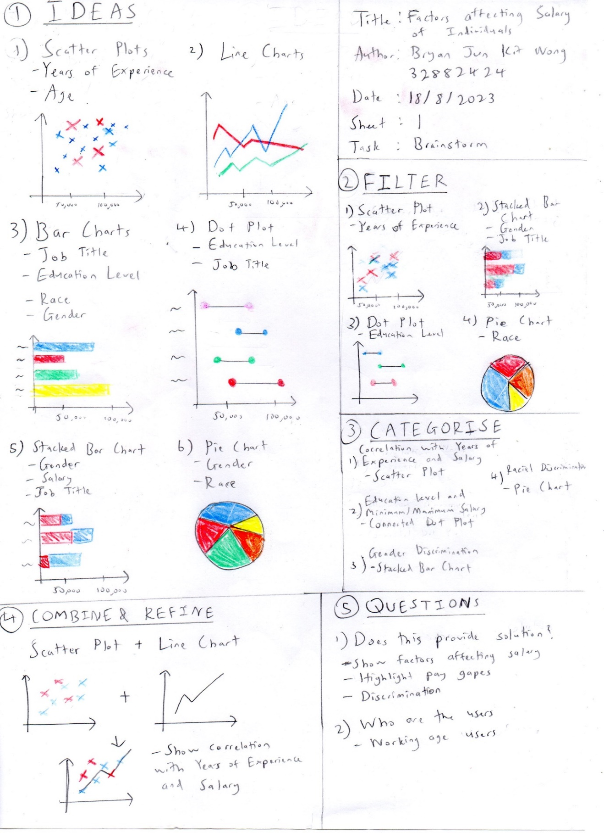

Figure 3.1: 5DS Sheet 1

**Sheet 2**

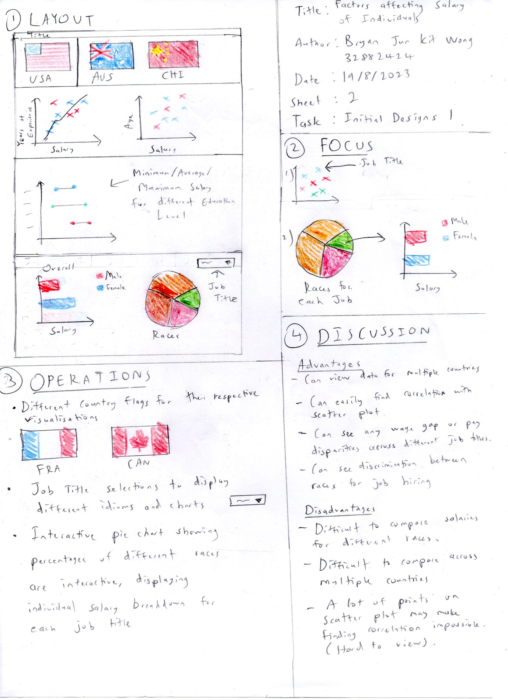

Figure 3.2: 5DS Sheet 2

**Sheet 3**

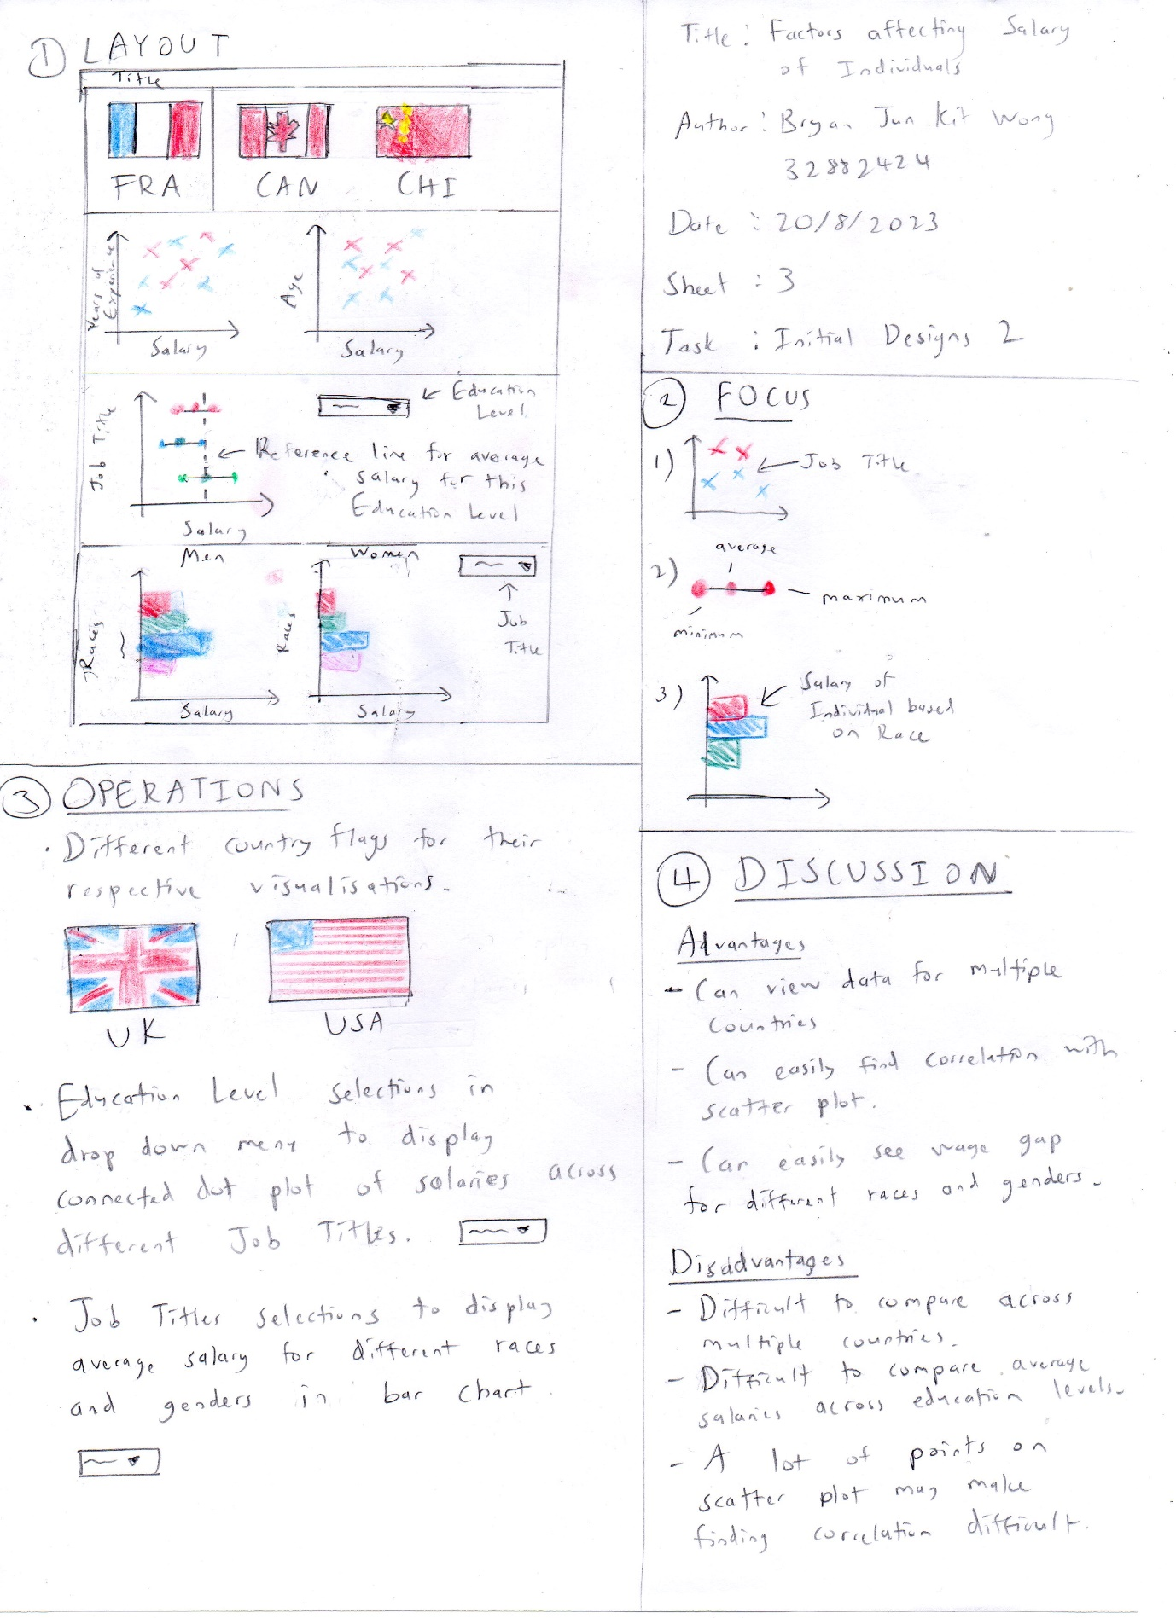

Figure 3.3: 5DS Sheet 3

**Sheet 4**

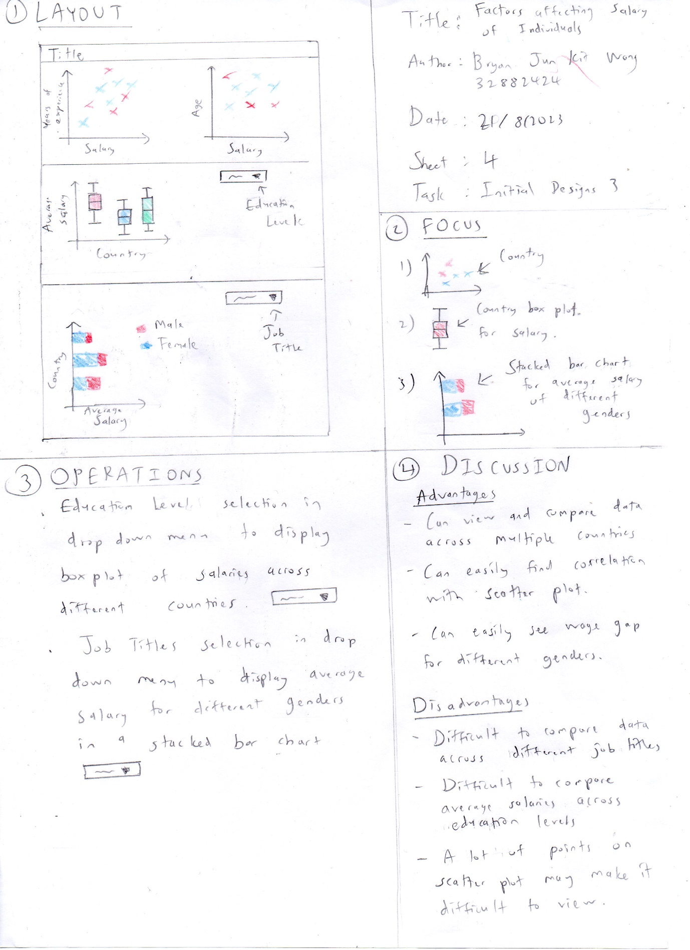

Figure 3.4: 5DS Sheet 4

**Sheet 5**

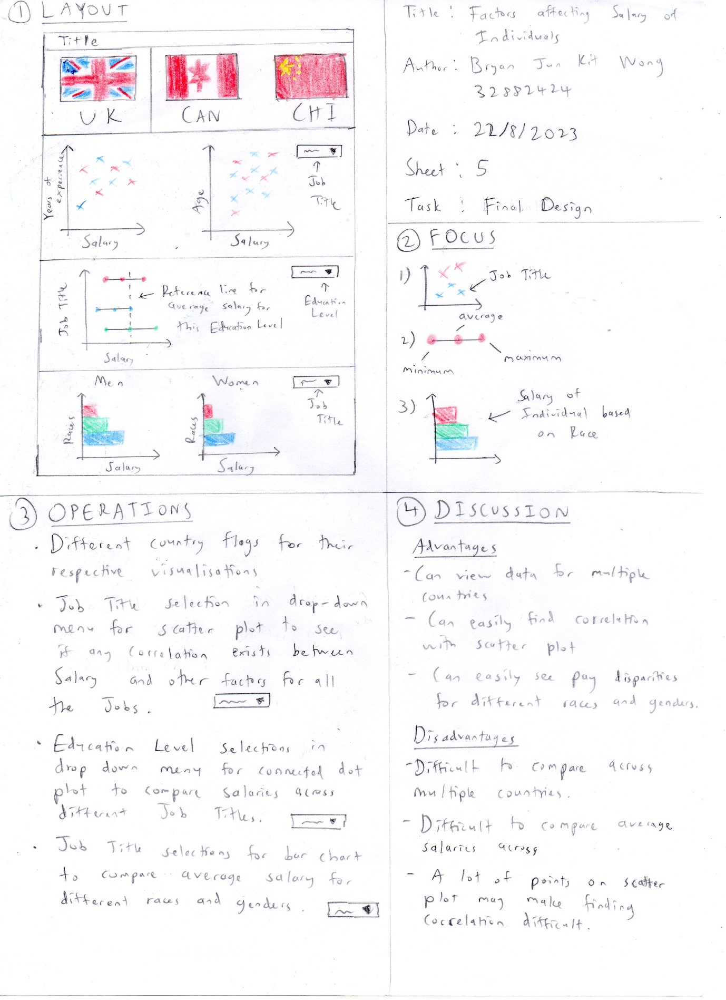

Figure 3.5: 5DS Sheet 5